**Day 5 - Testing, Error Handling, and Backend Integration Refinement**

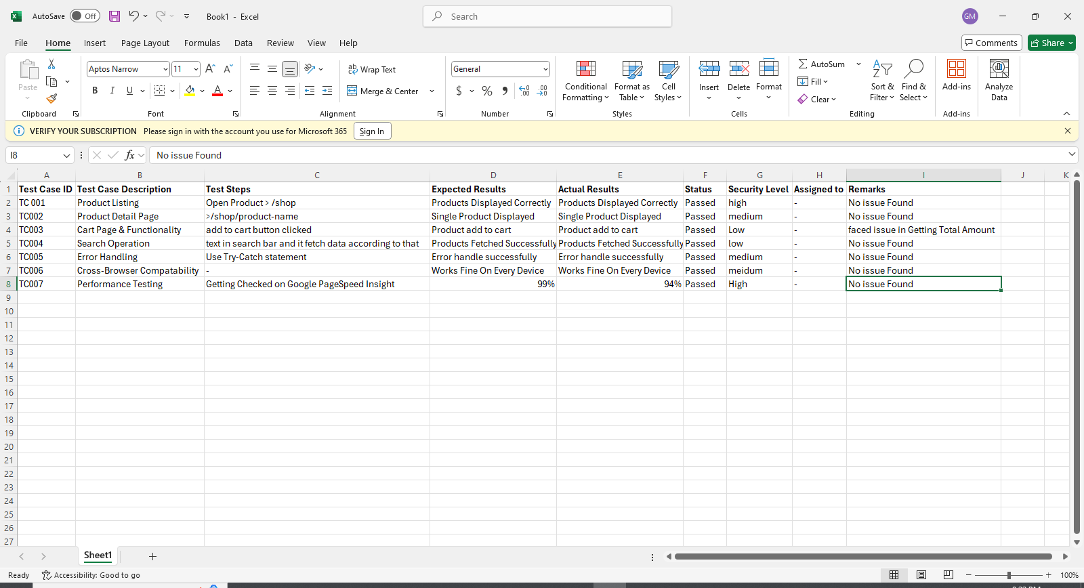

**Functional Testing**

**Test Case ID 001 - Product Listing:** Product shown in the below figure are rendered through Api.

**Path:** /shop

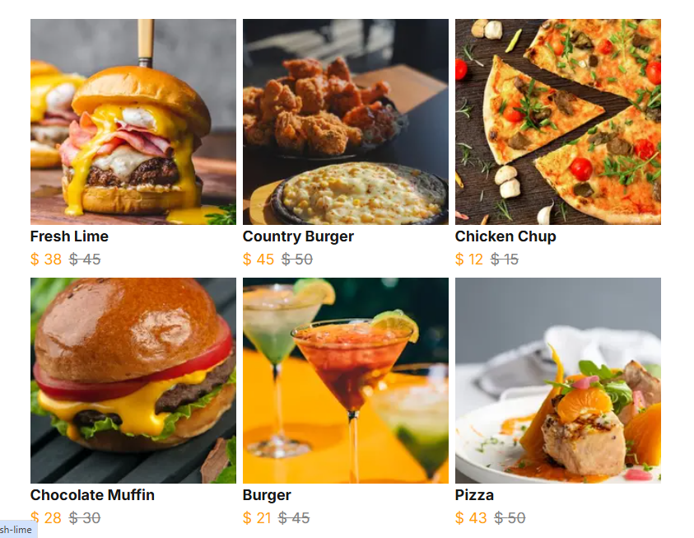

**Test Case ID 002 - Product Detail Page:** This product page is also rendered through sanity query and getting fetched by matching the slug of the product.

**Path:** /shop/product-slug

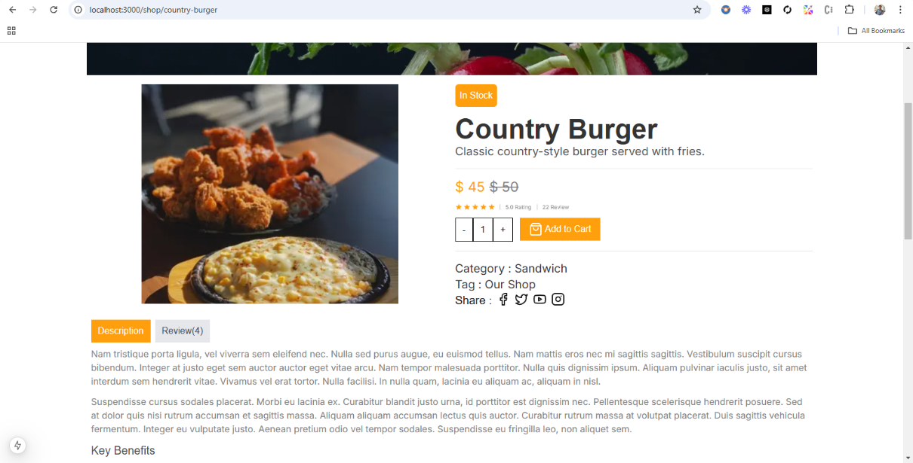

**Test Case ID 003 - Cart Operation:** When Add to Cart is clicked, it shows alert of Product added to the Cart first then the item is added to the cart.

**Path:** /cart.

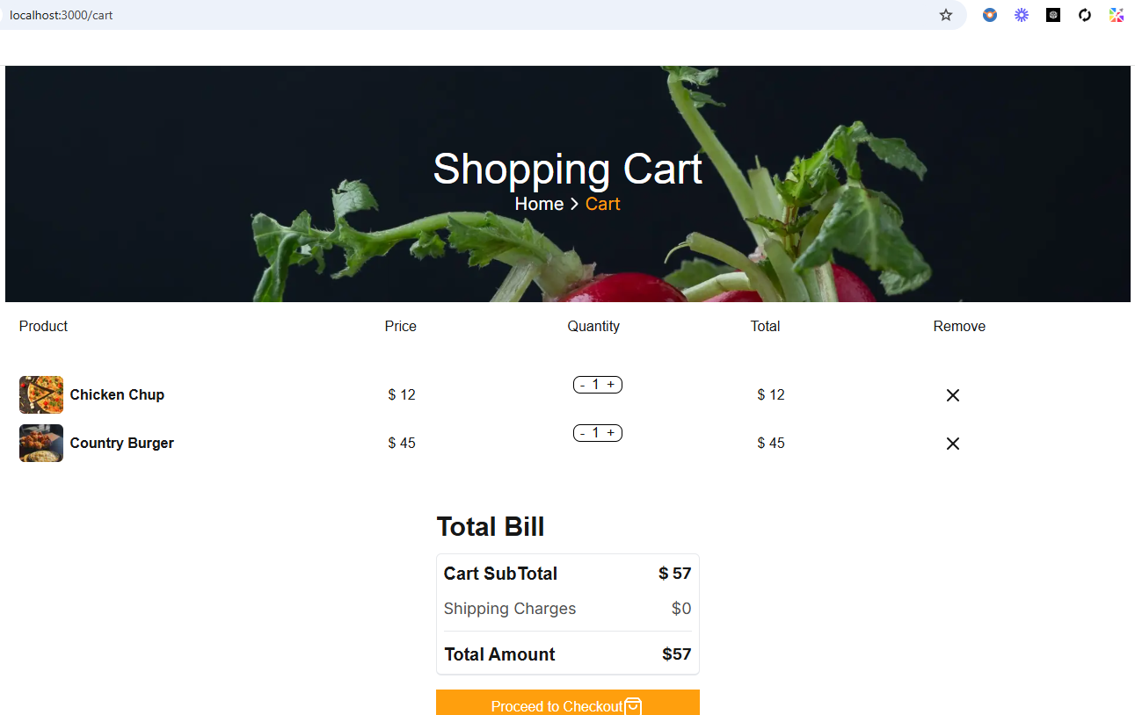

**Test Case ID 004 - Search Operation:** In Search Operation when any one hit enter, it take that value and matches that value of search to the product name and fetch that all products from sanity.

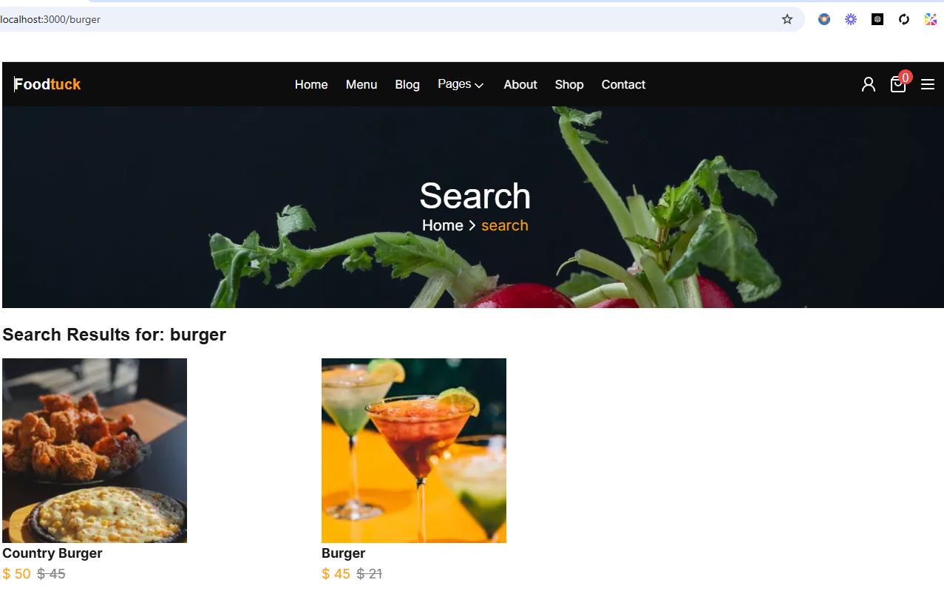

**Test Case ID 005 - Error Handling:** When there is any error on the backend it will show this message. This error shows because I have removed the GROQ query. And use try-catch statement for error handling

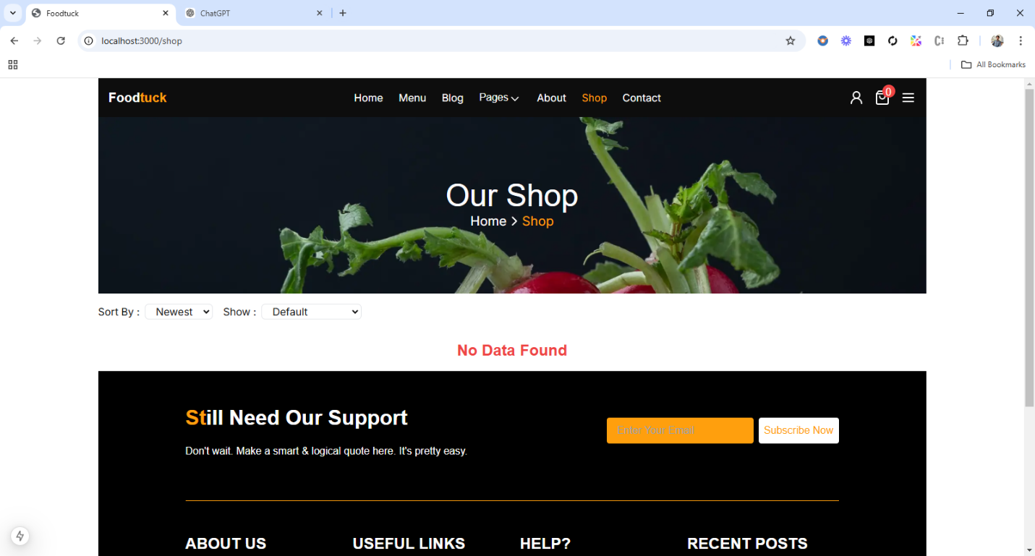

**Test Case ID 006 - Cross-Browser and Device Testing:**

**Chrome:**

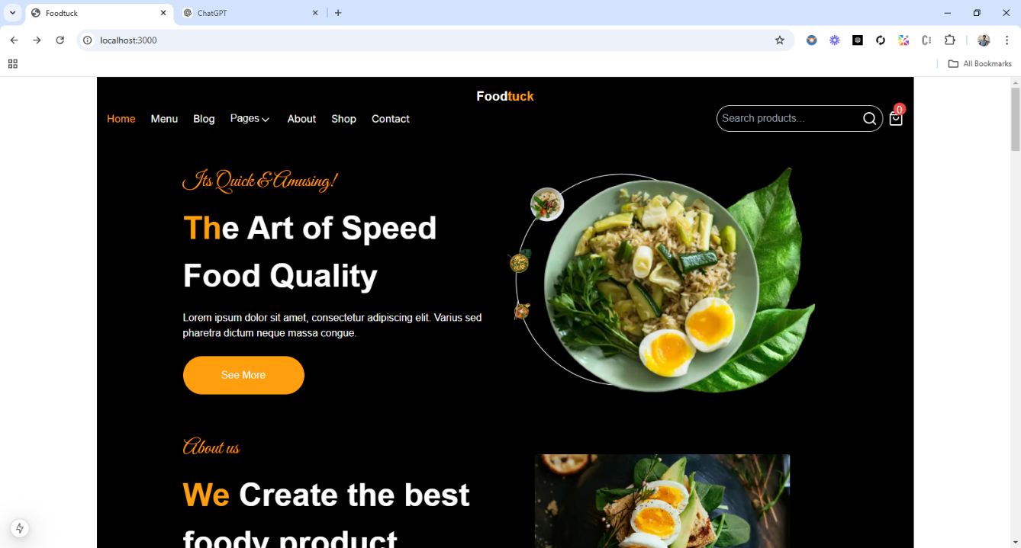

**Edge:**

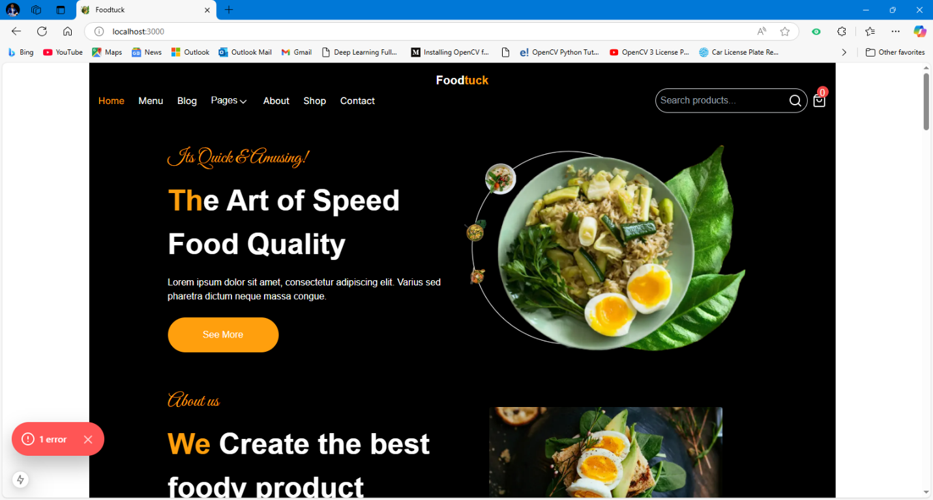

**Test Case ID 007 - Responsive:**

**Tablet:**

**Mobile:**

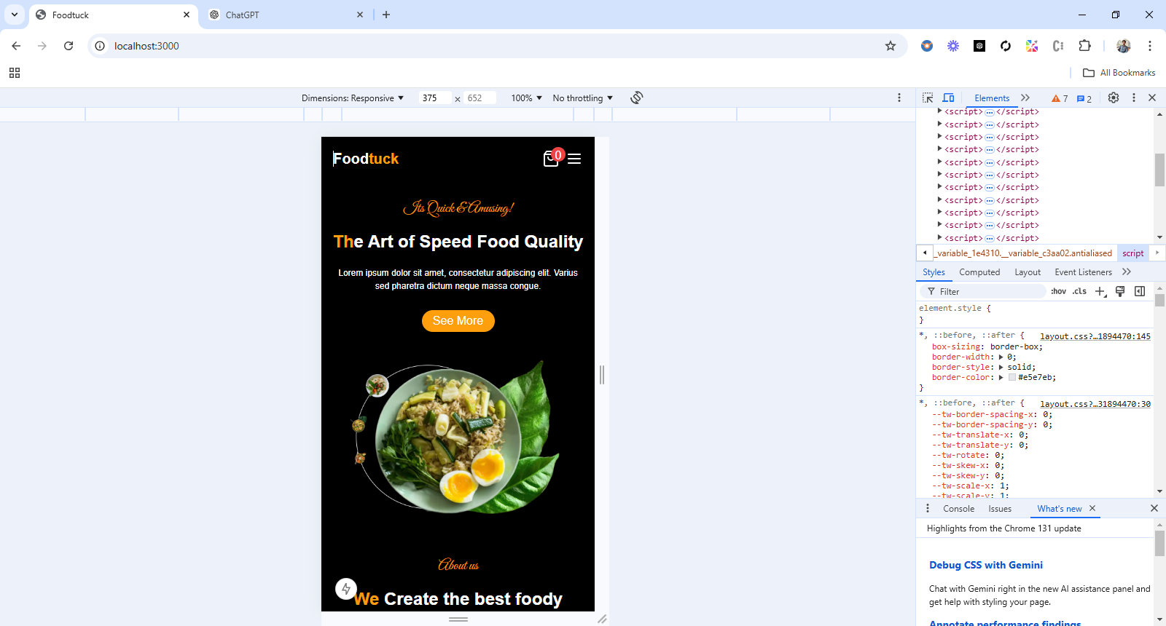 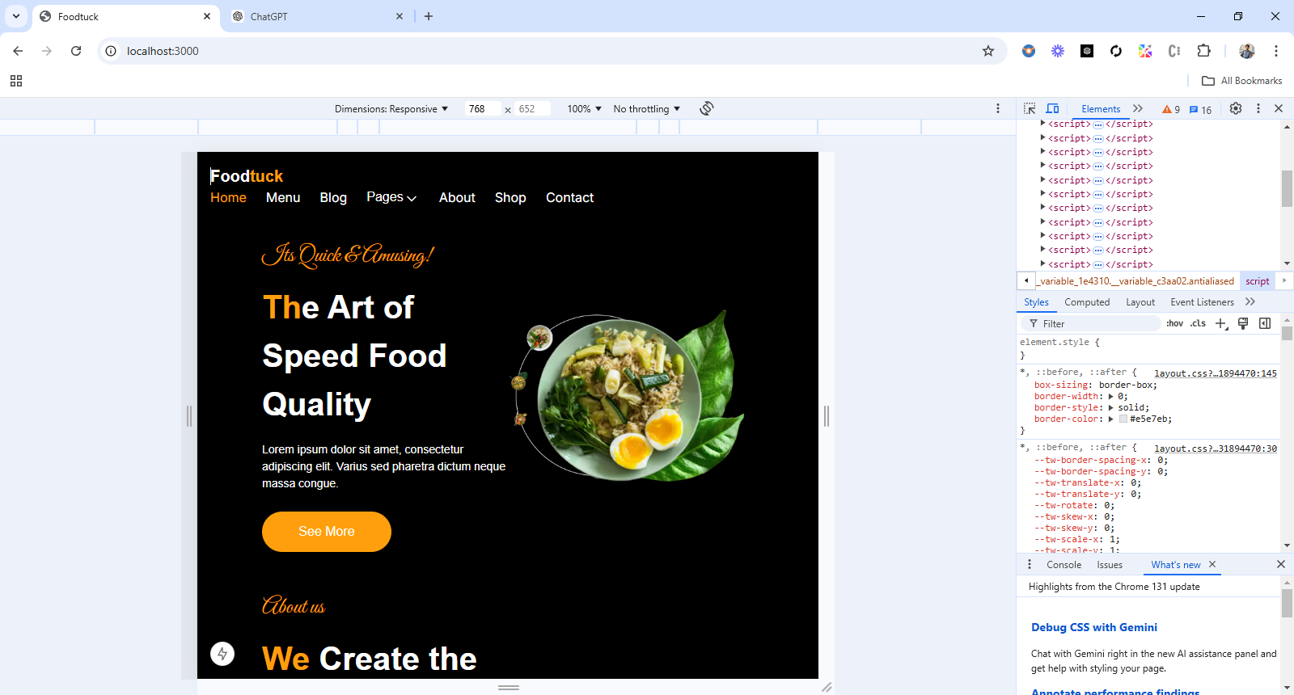

**Test Case ID 008 - Performance testing:**

